James Ledwith

A00196141

Final Report

3720 Words

**Introduction**

I have done my placement so far with the college. We have been given a room and a project to undertake at the start of the year. The lecturer acted as our project manager so he would give us a brief outline of what he wanted and we under took the task by splitting it up between the team. Initially there was three people in my group however as the project progressed more people were added to the team. The first few weeks were spent getting ourselves settled into the new working environment along with how we would tackle our new project. The project was to make a virtual simulation of the Athlone area with each member tackling a specific region. I was tasked with making the Athlone Institute of Technologies campus and various other parts to the simulation including the main menu and a transition mechanic. I was also the Scrum leader for the duration of the project so was very involved with the planning and allocation of work aspect to the project. The bulk of the project consisted of modelling out the campus area. The project we are working on is hopefully going to be used at the AIT open days and will be done with an oculus headset.

**Responsibilities and duties**

The roles and responsibilities I had over the course of the project were very varied. At the beginning of the semester I was working along-side Aidan. We were both tasked with making a virtual simulation of the Athlone area. I was the joint scrum leader at this stage and we both worked out what we should do between ourselves. We agreed what should be done and this continued for about 3 weeks. During this time we would check in with each other and see how we are getting on in a sort of stand-up meeting manner. The tasks we had to do were completed and they were done with no real planning it was done on a more hands on way. After the first 3 weeks we got another member in our group. This addition to the group added more structure to the group as we could now properly use Scrum as a development process. Scrum was used with two people in the group but it was hard to use effectively and enforce. I was appointed as Scrum leader for the first sprint and for this sprint we mainly worked on getting the entire planning done first. This was achieved through refinement of the user stories we had created. The user acceptance criteria were made by our group and then we would follow up with the lecturer (who acted as our product owner) and make sure that it was the correct criteria. This process of continually meeting up with the product owner and refining the user acceptance criteria continued until we all agreed that they were satisfactory. During this time as Scrum master I was also in charge of keeping a direct line of communication with the product owner. This was used to set up the meetings time and to let the product owner know if we were available and vice versa.

The next thing we had to do was plan the time it would take for each user story to be completed. To achieve this we used a method called poker planning. We all got a few cards with varying numbers based on the time it would take to complete a task from shortest to longest time. After we showed the time we would give our reasoning for the choice and share it with the group and we kept doing this until we came to an agreement. I put some of the user stories onto an online board made specifically for this task called Trello. I adjusted the poker planned times along with the user acceptance criteria under each user story. The criteria were done via checkboxes to give the group an indication of how complete the story was. There were three stages to the stories which were planned, in progress and done. A story would be completed when all the criteria is met and I allocated the stories to each member after asking which one they would prefer to tackle first. Each member of the Trello board has admin rights and can edit as they see fit. I was using an online app to do the poker planning as it was the most convenient to use. Below is Pictures of the Trello board. The picture on the left clearly shows how we used the above mentioned system of having user stories in three categories. The picture on the right shows how each user story was broken down into user acceptance criteria in checkbox form. The picture was an indication of what member was currently working on that user story to help keep track of who was on what and as a rule we stuck to one user story per person at a time to make sure no one was being over worked and also to ensure that each user story got done with the upmost quality that we could do.

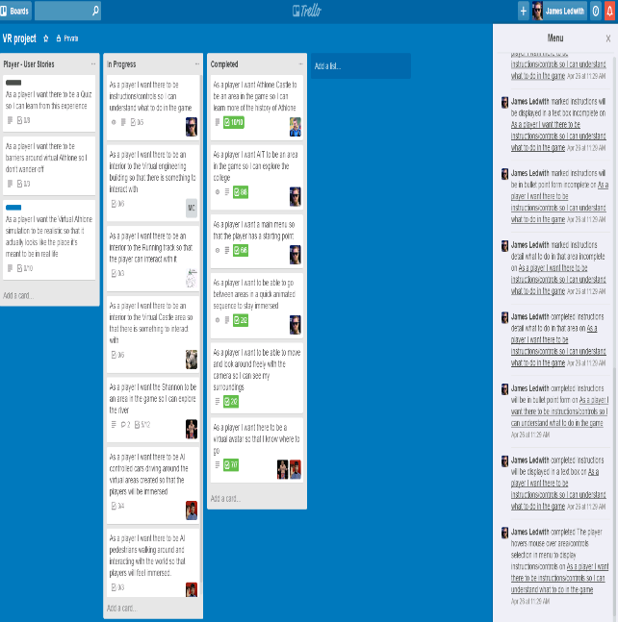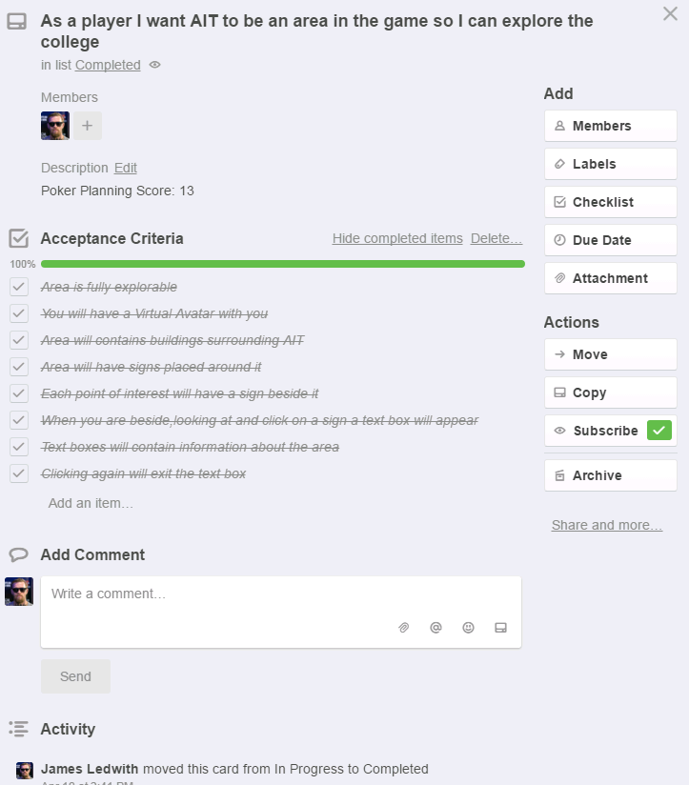

For the majority of the projects duration I was the main designer of the AIT campus virtual area. I was in charge of designing the code and approach to building the campus, creating the actual demo and texturing the models for the area. I was eventually the scrum of scrums leader when more people joined the group later on. This basically was handled by me by having a stand-up meeting each day with my second group to see how they were doing, what they planned to do and if they had encountered any problems. There was another meeting I had with the other scrum masters who were in my group from the start. These meetings with the scrum masters were less frequent than the ones with my initial group but they followed the same sort of guidelines as the other groups. I was also a part of this method by sharing with the group if I had any problems and what I had planned to do. I also created a sprint backlog chart which would take the tasks everyone had and show if we would be on track to make the sprint deadline. Below is a picture of the teams groups and tasks in the sprint backlog.

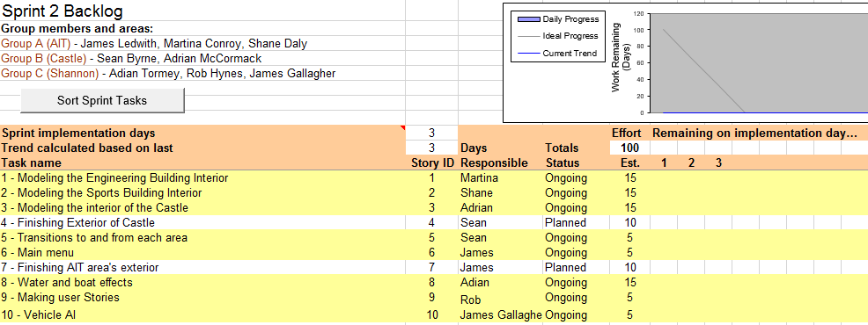

**Technical achievements**

The first few weeks were our initial sprint which consisted of a colleague and me. During this sprint I was working on a way to get a realistic terrain to mimic Athlone’s. Through research online I found that a plugin for unity could do that it basically worked by using a height map image of the area I wanted and it would out that image into the terrain in unity. After putting the image in and converting it into a terrain I had to scale it down to get a realistic look. There was the issue that this area was far too big but getting a height map of a smaller area was not possible. The next thing that I worked on was the moving platform and player holding mechanic. This would be used when we eventually had transportation in our simulation. The moving platform was done by getting two cubes with no mesh renderer and using them as the waypoints for the moving platform. The moving platform itself was another solid rectangle that would move between the waypoints back and forward in a continuous movement. The moving part of the platform was done by attaching a script with used a lerp function to go between the way points. I put a public variable into it so that the speed of the platforms could be changed at a later date if it needs to be and also it was good for testing. I made another script which would be attached to the moving platform that made the player controller a parent of the platform upon collision with each other.

After this I researched how to use and implement 3DS max as I thought it would be a good piece of software to use. This was installed on my computer but I had problems running it well and getting to grips with it. The 3DS max modelling was a bit too difficult for me to learn so I instead choose to try and use blender. The next thing I did with Blender was use it to create a test scene. There was also research with blender via videos to try and get a basic knowledge of it. After some time I found out that using Blender for modelling was very time consuming. It was also very difficult to generate the AIT campus area on it as it would all have to be hand modelled. This led me to do some research into another way to create the virtual simulation which would be efficient in making the area due to the time constraints we had. There was also the issue of having a working demo due at the end of every sprint so having a way to get that accomplished fast was a must. The way I came to tackle this problem was by using a piece of software called Sketchup. This allowed me to make a large area populated by roads and buildings very accurately. I had a practice area made in Sketchup and in this I tried to model the post office. This area was what I spend a week on and really helped me get to grips with the software. The textures for it were straight off google street view and this gave the building a realistic look. I also spent some time on the church building as well following the same principles. Below are pictures of them before I stopped and made my other area.

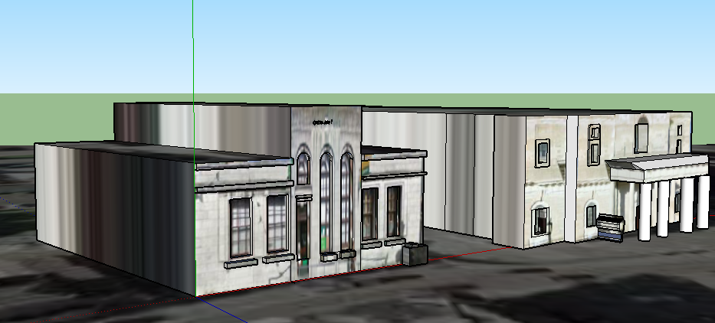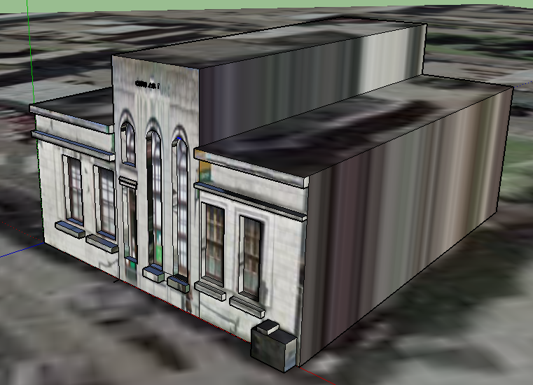

The second sprint was made up with another member who changed the way we went about things by following Scrum as an agile methodology. I was the scrum master for this sprint. I came up with some of the user acceptance criteria and user stories that should be used in the project. The poker planning was done next and that gave us a rough time of how long it would take to finish each user story. The next thing that I had to do was figure out how I would implement the user stories I had chosen to do into Unity. I started the Athlone campus area off in Sketchup by getting a birds-eye view image of the area. This area was imported into Sketchup which I used as the blueprint. The next part I worked on was the AIT engineering building. I made a square for the base and extruded it out. This process was continued for the whole building while including more lines and squares for detail. The more I modelled this building the easier it became and while doing this I kept measuring the building to keep it to scale. The next part was to texture the building. This was tackled by going outside around the building to take pictures of it as there were very limited resources of it online. The pictures were edited to make it easier to texture by cropping out redundant parts of the image. The pictures were then imported to Sketchup as textures. To get the textures to fit to the model I had to adjust them using an in-build tool and zooming in where necessary to get detail. The texture for the building was used as a blue print for the windows which followed the mentioned extruding process. This was done to add some depth/realism to the model. Below are pictures of the engineering building progress.

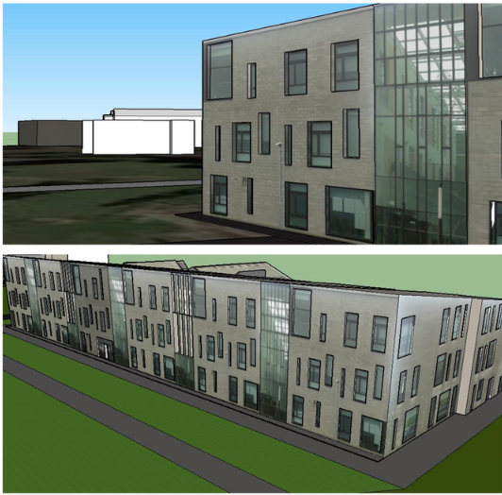

The next thing I did was using the picture of the area to fill in the paths, roads, car parks and buildings. This process entailed using the base picture as a guide to draw the lines around the areas. After I was finished this and happy with the result I raised up the height of everything on the base a small bit and coloured in the areas based on what they were (i.e. making all the paths the same colour). The Multipurpose hall was the next building I had to tackle and this followed the same method of modelling that the engineering building had. The MPH had less detail because there were only a few windows indented as I found that this process was very time consuming and cut this out to meet the deadlines. The indoor sports hall followed the same process again as did the business building and the hospitality building. All the other buildings excluding the Indoor sports track building had default textures put on them to save time and as a place holder until I could texture them properly. To bring the models into Unity was simple enough with it being directly exported as an .fbx file which included all the textures too it was just a case of scaling up the model and generating colliders so the controller would not fall through it. Throughout this projects lifecycle I have been using source control to commit and push changes. This was done on a regular basis so that I always had the most up to date version. I set up a repository at the beginning but it had a few problems with a team member so he set one up using a new account and it was fine from then on out.

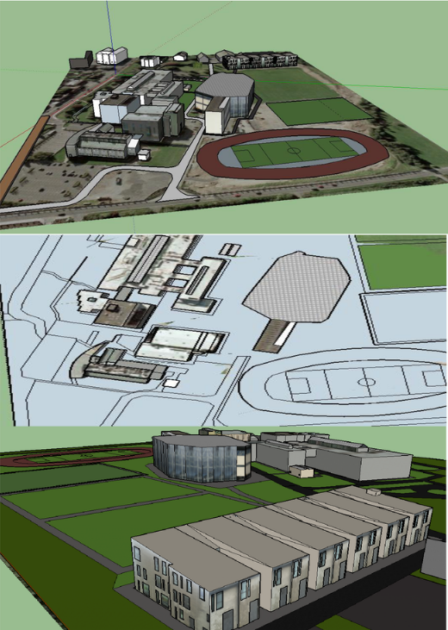

The main menu was another user story I chose to do. The menu has to various buttons including a controls, quit, quiz, AIT campus, Shannon and castle area button. The buttons all have a tooltip function that I put in. This allows text to be displayed upon being hovered over. This was done in unity by having the screen display a string of text inside a predefined area. This happened upon a mouse hovering over the button and then displays a blank string when the mouse is not hovered over the button. These actions are done through event triggers which are inbuilt to unity. This was added by me to give the user some indication of what to do and I thought it made the interface more user friendly. The menu had a level manager script that could be put on each button so that clicking the button would change the scene. Below you can see the main menus appearance along with what happens when you hover over the buttons. There is also the change scenes script.

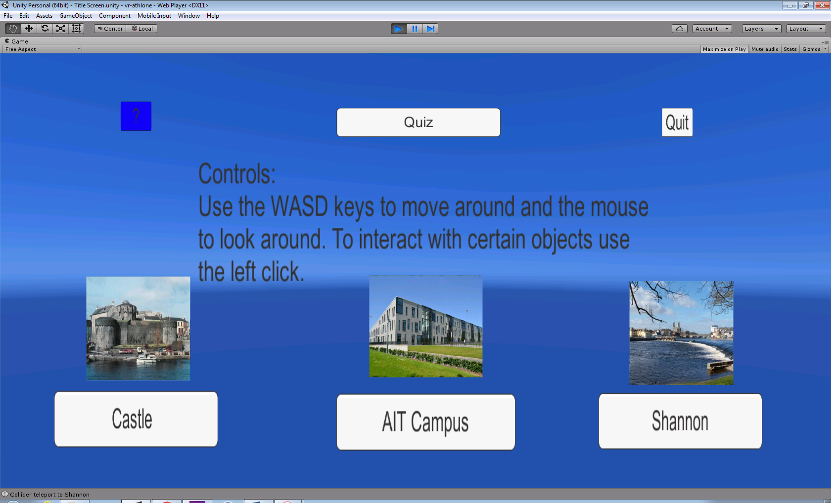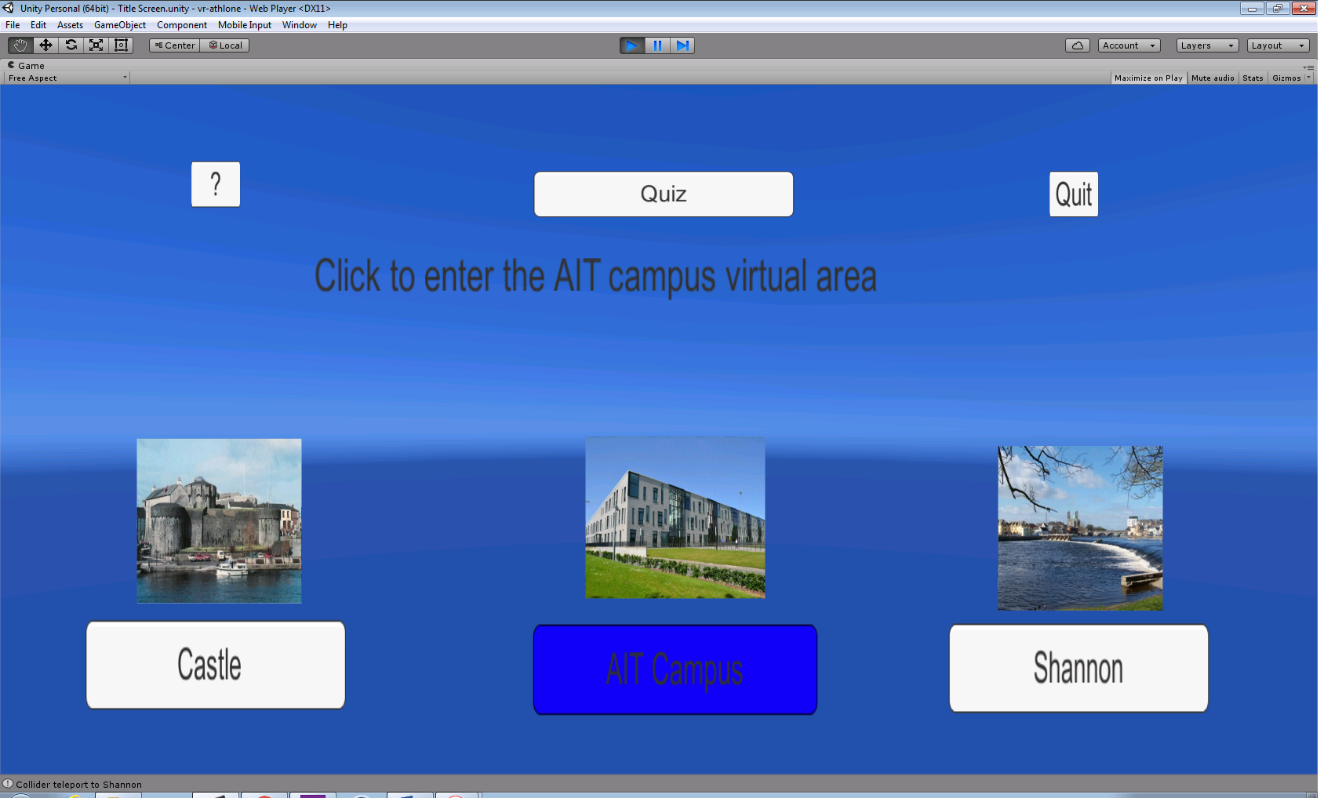

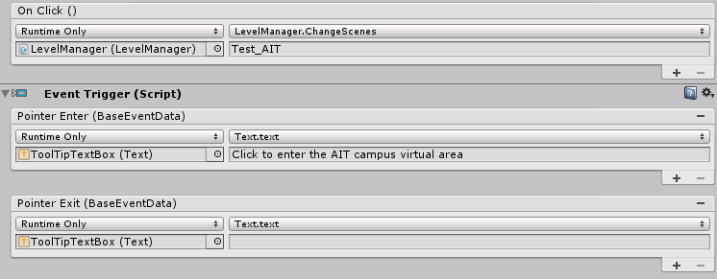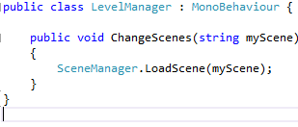

The mechanic for changing to each area was tackled by adding a sort of blink functionality. This would be triggered when the player changes from one scene to the next. The reasoning behind this was to make the transitions seem seamless and to add to the immersion. The way I went about this was having two animations. The first was for when the player entered a scene and this was an “eyes-open” animation. The second was when the player wanted to leave a location and would play the “eyes-close” animation. The animation was done by putting in two cubes in front of the players view and then making them very thin and colouring them black. These would be used to simulate the eyelids. I kept the eyelids just out of view and made the animation for each one. The animations are done in frames where it has movement generated in between them. These frames of the speed at which the animations play, were slowed down by me to give the animation a more natural feel. The next step was actually getting these animations to play which I accomplished by making a script. The script was added to the player controller and used tags for collisions. Basically when the player collides with an object that has a tag, it will play the close eyelid animation, wait and then load a new scene. The tricky part after this was done was getting the animations to wait a bit before changing scenes. I got it to work by adding in an enumerator and through trial and error of trying different times until the right seamless effect was created. The tags to each area were added to invisible cubes that I placed in my scene. The cubes had signs beside them to show where the player should go. Below is the code I made for the animations mentioned above and of the player controller with the eyelids in front of it. Then the third picture is of the cube colliding with the player and the animation playing.

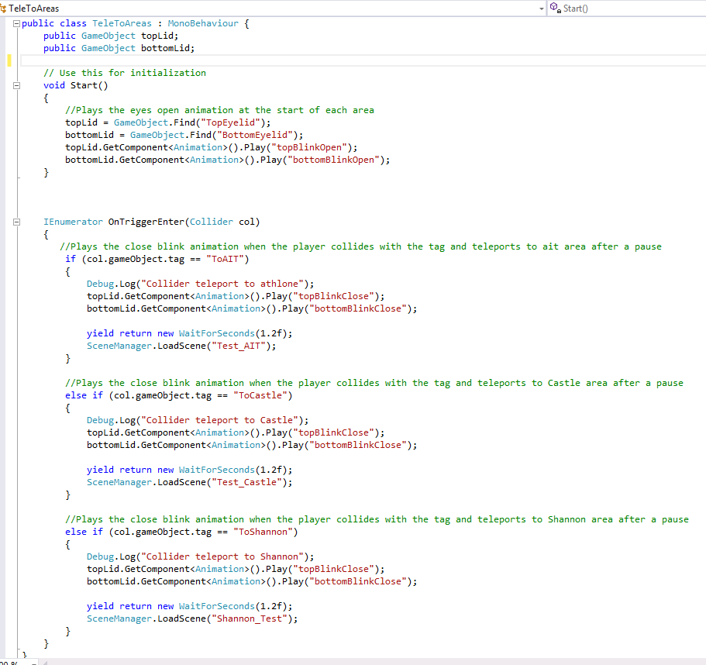

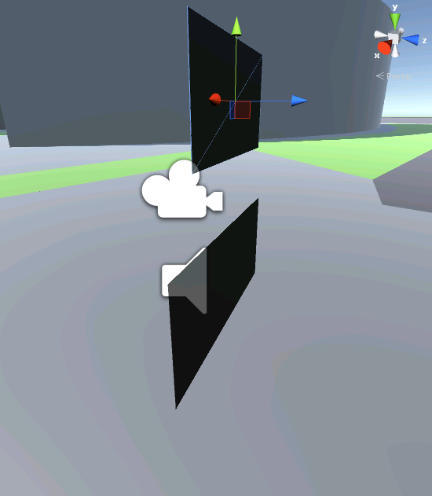

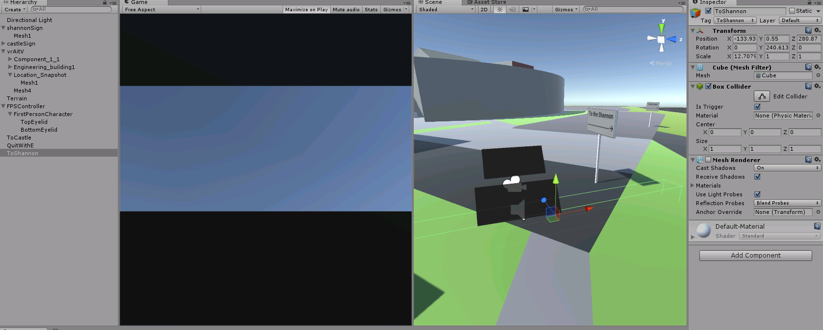

I also made a quit to the main menu script which was placed in my scene to give direct access to the menu when the “Q” key is pressed. This was simple to do with a few lines of code and was good for testing.

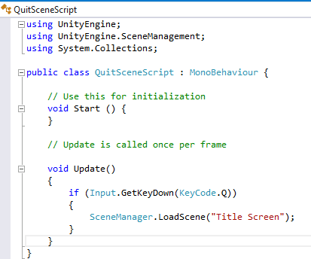

**Challenges**

There were a few challenges throughout the placement with the first being the room that we were allocated. The room was taken up every Tuesday by another class so using it effectively was an issue; however this was overcome by moving out of the room into a different one during this time during the week. Another problem was initially getting used to using the various new pieces of software including SketchUp and 3ds Max. The SketchUp issue was just a matter of spending some time watching tutorials and practicing with the software and eventually after some time I found that it was a delight to use and was very well suited to my needs for the project at hand. The 3ds Max software was another piece of software used which had the same problem but was only used for the initial few weeks of the placement so it did not become a major problem. The computers we used were lacking in the hardware area and this made it very difficult to run certain things like unity for instance which took a while to run and was very laggy. This eventually got to the point where I just used my laptop for any intensive process and then the college’s computer was used for research and Trello. The computers also did not have the required software that we were using and this was only rectified towards the end of our current sprint.

There was a problem initially with having a small group of two but as time went on this problem fixed itself as more people joined. Then ironically I found that when we had too many people that it was hard to plan for them and keep a track of work. The solution to this problem was to plan carefully what the team members would be doing and then stand-up meetings followed every morning alleviated the keeping track of progress problem.

There were not many pictures of the Athlone campus I was working on so I had to actually go out and take pictures of the campus using my phone. After the first sprint it became apparent that I needed to use a better camera so I went out again with a digital camera and this gave the desired result of realism and quality. Then there was an issue with the textures not importing from Sketchup into Unity initially. The problem was due to having the folder in the default location and with a default name but after I researched this problem a lot I found the solution was to move it to a new location with a different name.

**Analysis/Evaluation**

I found out through doing placement that a lot of valuable information can be learned in a few months. I have come to appreciate the development cycle using agile methodologies like Scrum. The importance of actually planning very well at the beginning of the product lifecycle was what I found very interesting. This was very evident in the first few weeks when we didn’t plan a lot and it took time to make progress. Then we planned before working after that and the development part was substantially easier. The Scrum method was suited well to our group and I have learned that sometimes you cannot exactly control the people or their ideas but you can influence the development process. The process of continually testing while I coded is also another thing that I will take away from this experience. I found it was much better to test as you code as opposed to testing at the very end. Doing testing in this manner reduced the amount of errors I made and also made them substantially easier to fix when they arose.

Through the use of various pieces of software I have also came to the realisation that it’s better to be able to learn new pieces of software and that it will come in beneficial for industry in the future. This is because I will be open to learning new programs and languages which will more than likely be encountered in my future career. The use of version control in our project using BitBucket and SourceTree was another thing that I think will be helpful for me in the future. Through using daily I have a much better understanding of how it is properly used. My understanding of scripting in C# has also improved throughout the course of this placement. The placement experience also thought me what it would be like to be in industry due to its 9 o’clock to 4 o’clock schedule. The schedule made me learn how to be punctual. The placement was handled very well in that we had regular meetings with our product owner which would happen in a real working environment. The skills I learned through emailing and helping set up meetings can be used later in industry.

**Conclusion**

In conclusion I found that placement was an excellent experience for me. It introduced me to new ideas and concepts. It also gave me valuable experience in practicing these concepts such as using planning, designing and testing for a project. The way the placement was handled was good and it felt like I was in industrial placement. I was very fortunate to get placement in the college and enjoyed working on a project as part of a team.